**InsightStream: Navigate the News Landscape (News App)**

**Ideation Phase**

**Brainstorm & Idea Prioritization**

|  |  |
| --- | --- |
| Date | 7 March 2025 |
| Team ID | SWTID1741172246152964 |
| Project Name | NewsApp:  BA LIVE NEWS |
| Maximum Marks | 4 Marks |

**Brainstorm & Idea Prioritization Template:**

**Brainstorming fosters a collaborative and open environment where team members contribute creative ideas to solve a problem effectively. The focus is on quantity over quality in the initial stages, encouraging out-of-the-box thinking. Once ideas are listed, we prioritize them based on their impact and feasibility.**

**This template helps your team organize ideas, structure discussions, and refine concepts for a successful news website development.**

**📌 Reference:** [**Mural Brainstorming Template**](https://www.mural.co/templates/brainstorm-and-idea-prioritization)

**Step-1: Team Gathering, Collaboration and Select the Problem Statement**

**Step-2: Brainstorm, Idea Listing and Grouping**

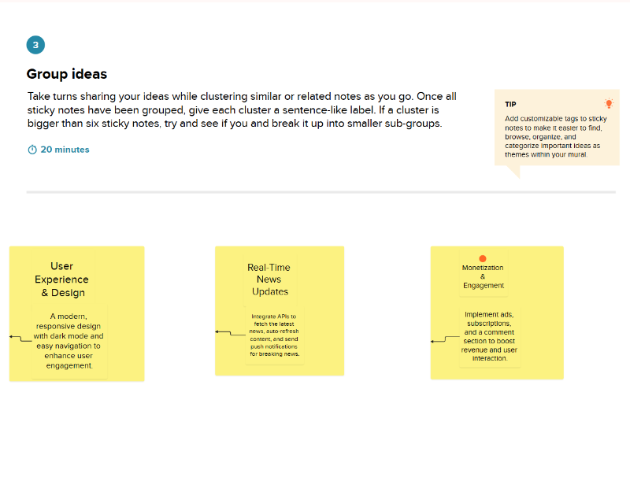

**Step-3: Idea Prioritization**

